**GAME3011 Assignment 4 Design Document**

**Chloe Ma (101260013) & Sojung Lee (101245044)**

**Hack Switch**

**Game Theme:**

This game has a futuristic theme – hence the blue & gray colors. The game mechanics and design were inspired by the hacking minigame, **System Shock 2**. I used the same grid layout. I also used the same winning conditions – select three consecutive tiles. I also used similar tile types – critical (ICE in System Shock 2) and blocked tiles. I incorporated player skills and hacking difficulty enumerators in my game while System Shock 2 used percentages. I also added a timer to my game (due to the assignment’s requirements).

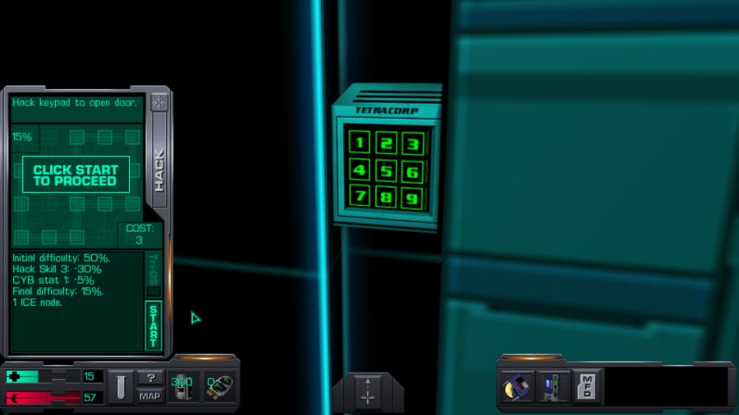

**Instructions:**

Click on the “Reset” button (top right corner) to start the game. Using your mouse, click (LMB) on the tiles & select three consecutive tiles to win the game (three vertical tiles or three horizontal tiles).

|  |  |
| --- | --- |
| Tile Type | Image |
| Selected Tiles |  |

Each time a user selects a tile, the next tile will also be selected **if** the next tile is not a critical tile. If the next tile is a critical tile, it will not be selected. This will give the user a hint what the next tile will be.

Hint: It is easier to win if the user tries to select three horizontal consecutive tiles since the next tile is revealed.

**How to Finish the Game (Win or Lose):**

1. Win the Game

Select three consecutive tiles (three green vertically or horizontally tiles).

1. Lose the Game
   1. Not completing the hack before the time runs out.
   2. Selecting/Clicking on the critical (blue) tile

**Information:**

Some tiles are randomized to two different types: blocked & critical.

|  |  |
| --- | --- |
| Tile Type | Image |
| Critical   * Game Over if clicked on * Usually hidden unless exposed (vary on player’s skill) |  |
| Blocked   * Not available to click on/select * Will not be counted for winning conditions |  |

Depending on the Player’s Skill and Hack Difficulty, the number of Critical & Blocked Tiles and the available time will vary.

Critical types are usually hidden. However, if the player skills are high, they can be exposed from the beginning of the game to make it easier for the user to complete the hack/game.

|  |  |  |
| --- | --- | --- |
| Player Skill | Timer | Exposed Tiles |
| New | 5 seconds | 0 |
| Intermediate | 10 seconds | 1 |
| Expert | 15 seconds | 2 |

The number of blocked tiles will be spawned more if the hack is difficult. The number of critical tiles will also increase.

|  |  |  |
| --- | --- | --- |
| Difficulty Level | Blocked Tiles | Critical Tiles |
| Easy | 0 Blocks | 1 Tile |
| Medium | 1 Block | 2 Tiles |
| Hard | 2 Blocks | 3 Tiles |

**HUD:**

The user can press the “Reset” button on the top right corner to restart the game (new Blocked tiles, new Critical Tiles, no Selected Tiles, new Hacking Levels & Skill Level, and timer restarts). The user can read the prompt and the game results on the top left corner. Pieces of information such as the player’s skill, hack’s difficulty level, and the timer countdown are displayed on the bottom right corner.

When the game finishes, the main menu button appears under the “Reset” button and the tiles are deactivated.